Two Page EUROSOI-ULIS 2025 Abstract - Title
Authors Name/s
Affiliations: dept. name, name of organization, acronyms acceptable, City, Country
e-mail address if desired

Abstract—This electronic document is a “live” template. The various components of your paper [title, text, heads, etc.] are already defined on the style sheet, as illustrated by the portions given in this document. (Abstract)

Introduction (Heading 1)
This template, modified in MS Word 2003 and saved as “Word 97-2003 & 6.0/95 – RTF” for the PC, provides authors with most of the formatting specifications needed for preparing electronic versions of their papers.

Ease of Use
The template is used to format your paper and style the text. All margins, column widths, line spaces, and text fonts are prescribed; please do not alter them. You may note peculiarities. For example, the head margin in this template measures proportionately more than is customary. This measurement and others are deliberate, using specifications that anticipate your paper as one part of the entire proceedings, and not as an independent document. Please do not revise any of the current designations.

Styling Notes
Do not use hard tabs, and limit use of hard returns to only one return at the end of a paragraph. Do not add any kind of pagination anywhere in the paper. Do not number text heads-the template will do that for you.

Abbreviations and Acronyms (Heading 2)
Define abbreviations and acronyms the first time they are used in the text, even after they have been defined in the abstract. Abbreviations such as IEEE, SI, MKS, CGS, sc, dc, and rms do not have to be defined. Do not use abbreviations in the title or heads unless they are unavoidable.

Units
- Use either SI (MKS) or CGS as primary units. (SI units are encouraged.) English units may be used as secondary units (in parentheses). An exception would be the use of English units as identifiers in trade, such as “3.5-inch disk drive”.
- Avoid combining SI and CGS units, such as current in amperes and magnetic field in oersteds. This often leads to confusion because equations do not balance dimensionally. If you must use mixed units, clearly state the units for each quantity that you use in an equation.
- Use a zero before decimal points: “0.25”, not “.25”. Use “cm3”, not “cc”. (bullet list)

Equations
The equations are an exception to the prescribed specifications of this template. Your equations should use either Times New Roman or Symbol font. To create multileveled equations, it may be necessary to treat the equation as a graphic and insert it into the text after your paper is styled. Number equations consecutively. Equation numbers, within parentheses, are to position flush right, as in (1), using a right tab stop. Punctuate equations with commas or periods when they are part of a sentence, as in
       
Note that the equation is centered using a center tab stop. Be sure that the symbols in your equation have been defined before or immediately following the equation.

Using the Template
After the text edit has been completed, the paper is ready for the template.

Authors and Affiliations
The template is designed so that author affiliations are not repeated each time for multiple authors of the same affiliation. Please keep your affiliations as succinct as possible (for example, do not differentiate among departments of the same organization).

Figures and Tables

Positioning Figures and Tables: Place figures and tables at the second page, below the text. Large figures and tables may span across both columns. Figure captions should be below the figures; table heads should appear above the tables. All figures and tables should be cited in the text. Use the abbreviation “Fig. 1”, even at the beginning of a sentence.

Figure Labels: Use 8 point Times New Roman for Figure labels. Use words rather than symbols or abbreviations when writing Figure axis labels to avoid confusing the reader. As an example, write the quantity “Magnetization”, or “Magnetization, M”, not just “M”. If including units in the label, present them within parentheses. Do not label axes only with units. In the example, write “Magnetization (A/m)”, not just “A/m”. Do not label axes with a ratio of quantities and units. For example, write “Temperature (K)”, not “Temperature/K”.

Acknowledgment (Heading 5)
The preferred spelling of the word “acknowledgment” in America is without an “e” after the “g”.

References
The template will number citations consecutively within brackets [1]. The sentence punctuation follows the bracket [2]. Refer simply to the reference number, as in [3], do not use “Ref. [3]” or “reference [3]” except at the beginning of a sentence: “Reference [3] was the first… ”. The references should be detailed following the IEEE Style. The reference list should be written as in the examples given hereafter for articles in journals [1], books [2], papers in a contributed volume [3], and thesis or unpublished work [4].
- M. Ito et al., “Can the application of amorphous oxide TFT be an electrophoretic display?,” J. Non-Cryst. Solids, vol. 354, no. 19, pp. 2777–2782, Feb. 2008.
- E. Borger, Computability, Complexity, Logic (North-Holland, Amsterdam, 1989).
- A.K. Lenstra and H.W. Lenstra, Jr., Algorithms in number theory, in: J. van Leeuwen, ed., Handbook of Computer Science, Vol. A (Elsevier, Amsterdam, 1990) 673-715.
- A. Rajasekar, Semantics for logic programs, Ph.D. Thesis, Department of Computer Science, University of Maryland, 1989.

- Table Type Styles
Table Head | Table Column Head
Table Head | Table column subhead | Subhead | Subhead
copy | More table copyª
a. Sample of a Table footnote. (Table footnote)

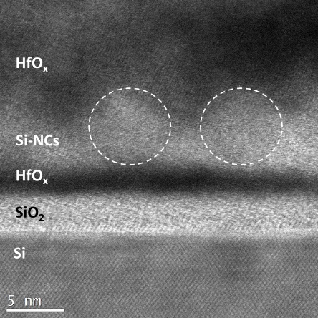
- Example of a figure caption. (figure caption)
We suggest that you use a text box to insert a graphic (which is ideally a 300 dpi JPEG, TIFF or EPS file, with all fonts embedded).

